**Experiment no: 06**

**Date: 27.08.2025**

Data Visualization using Power Bi

**AIM:**

To visualize and analyse employee data using Power BI by connecting data sources, transforming data, and creating an interactive dashboard with key insights.

# Dataset Description:

The dataset contains records of employees, covering demographic, job, and performance details.

Key columns include:

* Employee_ID: Unique identifier
* Department, Job_Title: Work and role details
* Gender, Age, Education_Level: Demographic info
* Monthly_Salary, Years_At_Company: Employment details
* Performance_Score, Employee_Satisfaction_Score: Evaluation metrics
* Remote_Work_Frequency, Promotions, Resigned: Work behavior indicators Total attributes: 19 columns, each providing insights into workforce trends, performance, and satisfaction.

# Process:

1. Data Preparation
   * Imported the CSV dataset into Power BI Desktop.
   * Used Power Query Editor to:
     + Correct data types (e.g., dates, numeric fields).
     + Remove unnecessary columns.
     + Promote headers and ensure data consistency.
2. Measures and Calculations Created calculated metrics:
   * Average Salary
   * Average Satisfaction Score
   * Resignation Rate

Used these as KPIs in the dashboard.

1. Visualizations Created

Six visuals were built to display employee insights:

1. Bar Chart – Employees by Monthly Salary
2. Line Chart – Employee Count by Year
3. Scatter Plot – Satisfaction vs. Performance
4. Column Chart – Average Salary by Job Title
5. Donut Chart – Remote Work Frequency
6. Column Chart – Department by Gender
7. Dashboard Design
   * Professional dark background with gradient style.
   * Consistent color palette for clarity.
   * Added slicers and filters for interactivity.
   * Combined visuals to highlight workforce diversity, job trends, and performance patterns.

# Output:

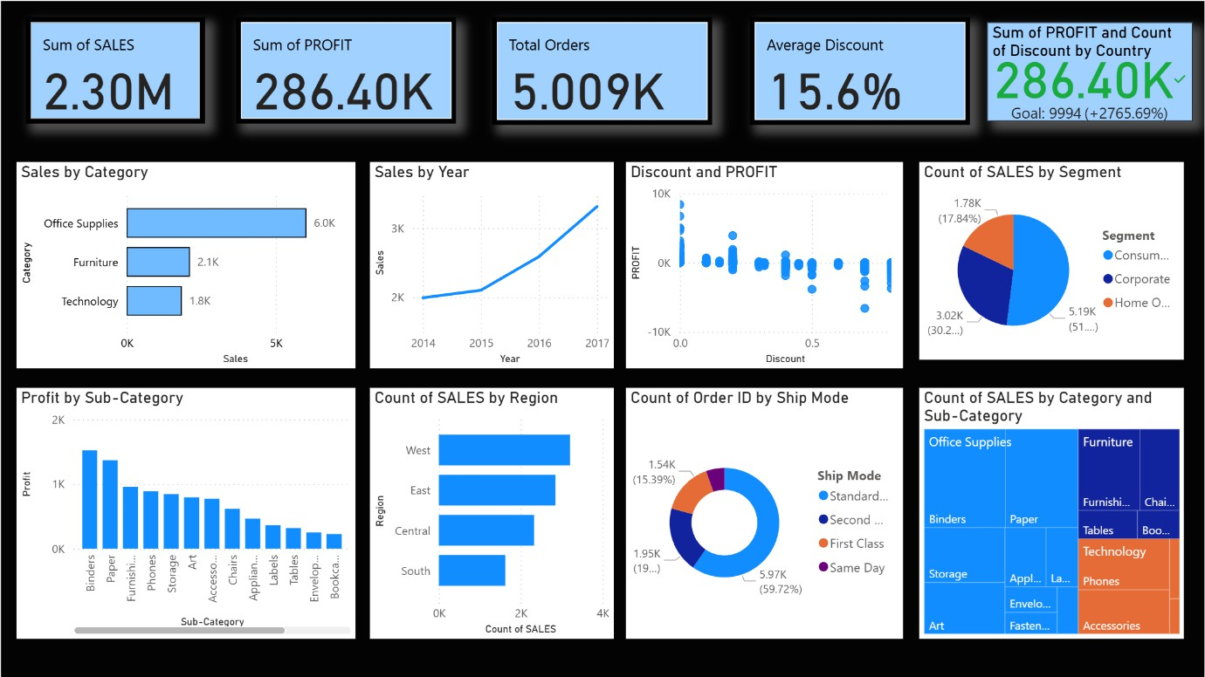

**Observation:**

The Power BI dashboard effectively visualizes employee data, revealing trends in salary, job roles, satisfaction, and gender distribution. It demonstrates how visual analytics enhances HR insights and decision-making.

# Result:

A complete Power BI dashboard was created using an employee dataset, including six visuals and key KPIs, providing meaningful insights into workforce structure and performance.